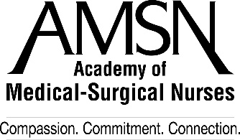

2019 Annual Convention Meeting Space Request Form
September 26-29, 2019
Hilton Chicago - Chicago, IL

AMSN will make meeting space available to qualified representatives on a first-come, first-served basis. To reserve a meeting room, you must complete this form. AMSN will qualify your request and, when approved, we will notify you and the hotel. At that time, you are responsible for coordinating all arrangements, instructions, etc., directly with the hotel. AMSN will not make these arrangements on your behalf, but simply ensures that you qualify to reserve meeting space in conjunction with the meeting.

Firm Requesting Space

Contact Person Title

Address

City State ZIP

Phone FAX E-mail

Onsite Contact Person w/cell # (if different from above)________________________________________________

Function or Event Name

Function Date(s) and Times(s)

Expected Attendance Meeting Space Set-up ________________________

Purpose

Signature Date

Please return form to: Academy of Medical-Surgical Nurses
P. O. Box 56
Pitman, NJ 08071-0056
Attention: Rachel DeAngelo, Conference Coordinator
Phone 856-256-2430, Fax 856-589-7463 – rachel.deangelo@ajj.com

*** FOR OFFICE USE ONLY***

Meeting approved by Date of Approval
Location Date Assigned
Meeting Room Date/Time
Facility Contact Ph/Email
AV Contact Ph/Email

